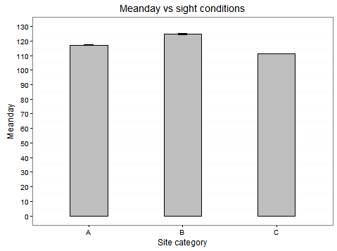

A=High lc.shallow slope & Low lc.steep slope

B=high lc.steep slope

C=low lc.shallow slope